DSA0111 CO3-AT1 Analytical Problem Solving

Question 1: Banking Account Management System
A banking application needs to create and manage customer account objects. The system should support different ways of initializing an account depending on the information available.
Design a C++ program using a class Account with the following constructors: Default constructor – initializes an account with default values.
Parameterized constructor – initializes account number, customer name, and balance. Copy constructor – creates a new account by copying the details of an existing account.
Tasks:
1. Define the Account class with suitable data members.
2. Implement the default, parameterized, and copy constructors.
3. Create objects using each constructor.
4. Display the details of each account.
5. Analyze and explain how object initialization differs for the three constructors. 6. Create a new account object from an existing account object using the copy constructor.
7. Predict and explain the order in which constructors are called during object creation and copying.

CODING:

#include <iostream>
using namespace std;

class Account {
int accNo;
string name;
double balance;
public:
Account() {
accNo = 0;
name = "Unknown";
balance = 0.0;
cout << "Default constructor called\n";
}
Account(int a, string n, double b) {
accNo = a;
name = n;
balance = b;
cout << "Parameterized constructor called\n";
}
Account(const Account &other) {
accNo = other.accNo;
name = other.name;
balance = other.balance;
cout << "Copy constructor called\n";
}
void display() {
cout << "Account No: " << accNo << ", Name: " << name << ", Balance: " << balance << endl;
}
};

int main() {
Account a1;
a1.display();

Account a2(101, "Suba", 5000.50);
a2.display();

Account a3(a2);
a3.display();

return 0;
}

OUTPUT:

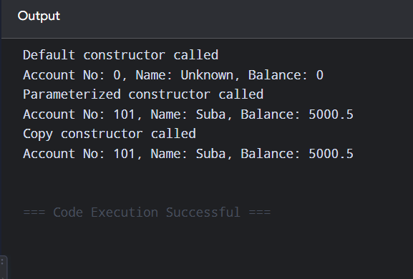

Question 2: Inventory Product Management System
A software company is developing an inventory management system using a class called Product. The system should allow products to be created, copied, combined, and removed from memory. Write a complete C++ program for the Inventory Product Management System using a parameterized constructor, copy constructor, destructor, and overloaded + operator. Demonstrate the complete object lifecycle through suitable output statements
Analyze:
1. Design the Product class with appropriate data members.
2. Implement a parameterized constructor to initialize product details. 3. Implement a copy constructor to duplicate a product.
4. Implement a destructor to release resources when an object is destroyed. 5. Overload the + operator to add the stock quantities of two products. 6. Create two product objects using the parameterized constructor.
7. Create another product using the copy constructor.
8. Add two products using the overloaded + operator.
9. Display the product details and resulting stock quantity.
10. Trace and explain the sequence of constructor and destructor calls.

CODING:

#include <iostream>
using namespace std;

class Product {
string name;
int stock;
public:
Product(string n, int s) {
name = n;
stock = s;
cout << "Parameterized constructor called\n";
}
Product(const Product &p) {
name = p.name;
stock = p.stock;
cout << "Copy constructor called\n";
}
~Product() {
cout << "Destructor called for " << name << endl;
}
Product operator+(const Product &p) {
return Product(name + "&" + p.name, stock + p.stock);
}
void display() {
cout << "Product: " << name << ", Stock: " << stock << endl;
}
};

int main() {
Product p1("Laptop", 10);
Product p2("Mouse", 20);

Product p3(p1);
p3.display();

Product p4 = p1 + p2;
p4.display();

return 0;
}

OUTPUT:

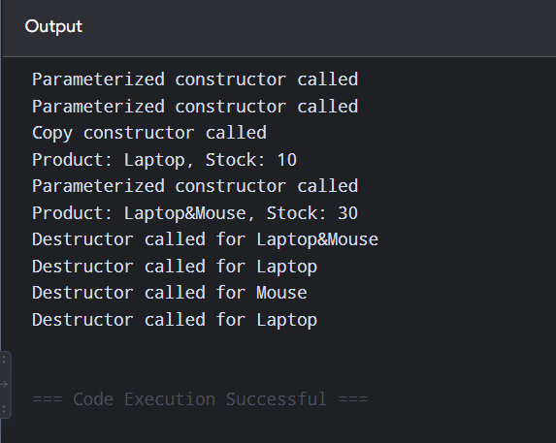

Question 3: Shopping Cart Management System
An online shopping application maintains customer shopping carts. A cart contains multiple products and their quantities. The system should support creating a cart, duplicating an existing cart, and merging two carts. Write a complete C++ program to implement the ShoppingCart system. Demonstrate parameterized construction, copy construction, cart merging using +, and destruction of objects.
Tasks:
1. Design the Product class with appropriate data members.
2. Implement a parameterized constructor to initialize product details. 3. Implement a copy constructor to duplicate a product.
4. Implement a destructor to release resources when an object is destroyed. 5. Overload the + operator to add the stock quantities of two products. 6. Create two product objects using the parameterized constructor. 7. Create another product using the copy constructor.
8. Add two products using the overloaded + operator.
9. Display the product details and resulting stock quantity.
10. Trace and explain the sequence of constructor and destructor calls. 11. Explain what may happen if dynamically allocated memory is not released in the destructor

CODING:
#include <iostream>
#include <vector>
using namespace std;

class Product {
string name;
int qty;
public:
Product(string n, int q) {
name = n;
qty = q;
cout << "Product created: " << name << endl;
}
Product(const Product &p) {
name = p.name;
qty = p.qty;
cout << "Product copied: " << name << endl;
}
~Product() {
cout << "Product destroyed: " << name << endl;
}
Product operator+(const Product &p) {
return Product(name + "&" + p.name, qty + p.qty);
}
void display() {
cout << "Product: " << name << ", Qty: " << qty << endl;
}
};
class ShoppingCart {
vector<Product> items;
public:
ShoppingCart(vector<Product> p) : items(p) {
cout << "Cart created\n";
}
ShoppingCart(const ShoppingCart &c) : items(c.items) {
cout << "Cart copied\n";
}
~ShoppingCart() {
cout << "Cart destroyed\n";
}
ShoppingCart operator+(const ShoppingCart &c) {
vector<Product> merged = items;
merged.insert(merged.end(), c.items.begin(), c.items.end());
return ShoppingCart(merged);
}
void display() {
for (auto &p : items) p.display();
}
};

int main() {
Product p1("Book", 2);
Product p2("Pen", 5);

ShoppingCart c1({p1, p2});
c1.display();
ShoppingCart c2(c1);
c2.display();
ShoppingCart c3 = c1 + c2;
c3.display();

return 0;
}

OUTPUT:

